**Tableau**

by Vishal Kumar Singh  
MCA-ss (2019272041)

**Heatstroke/ Heart disease Prediction and Analysis Using Tableau**

**Analysis of the dataset**

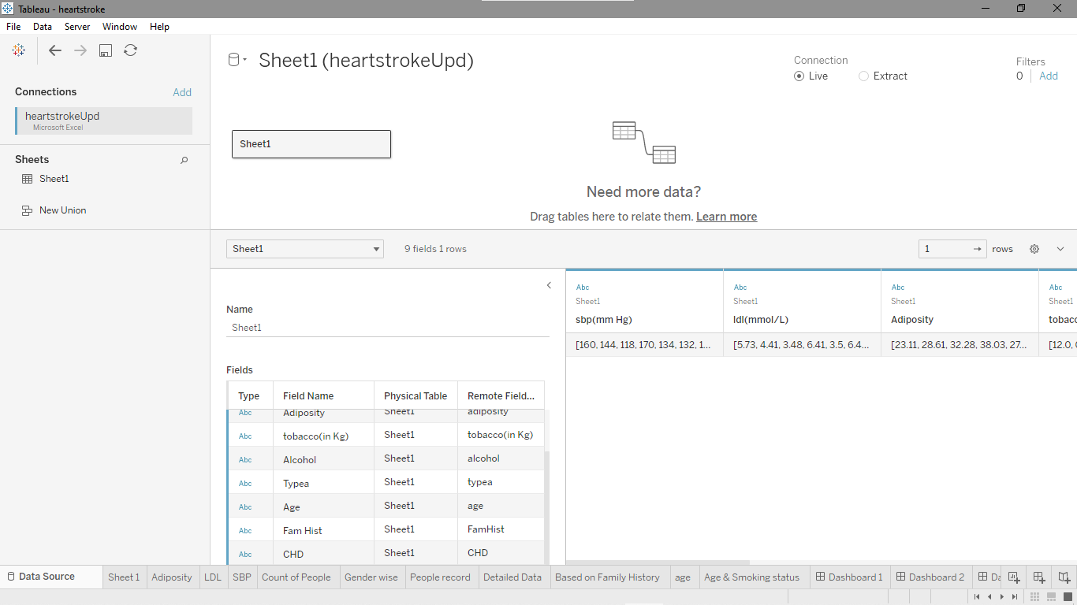

* Count of people based on cardiovascular and adiposity

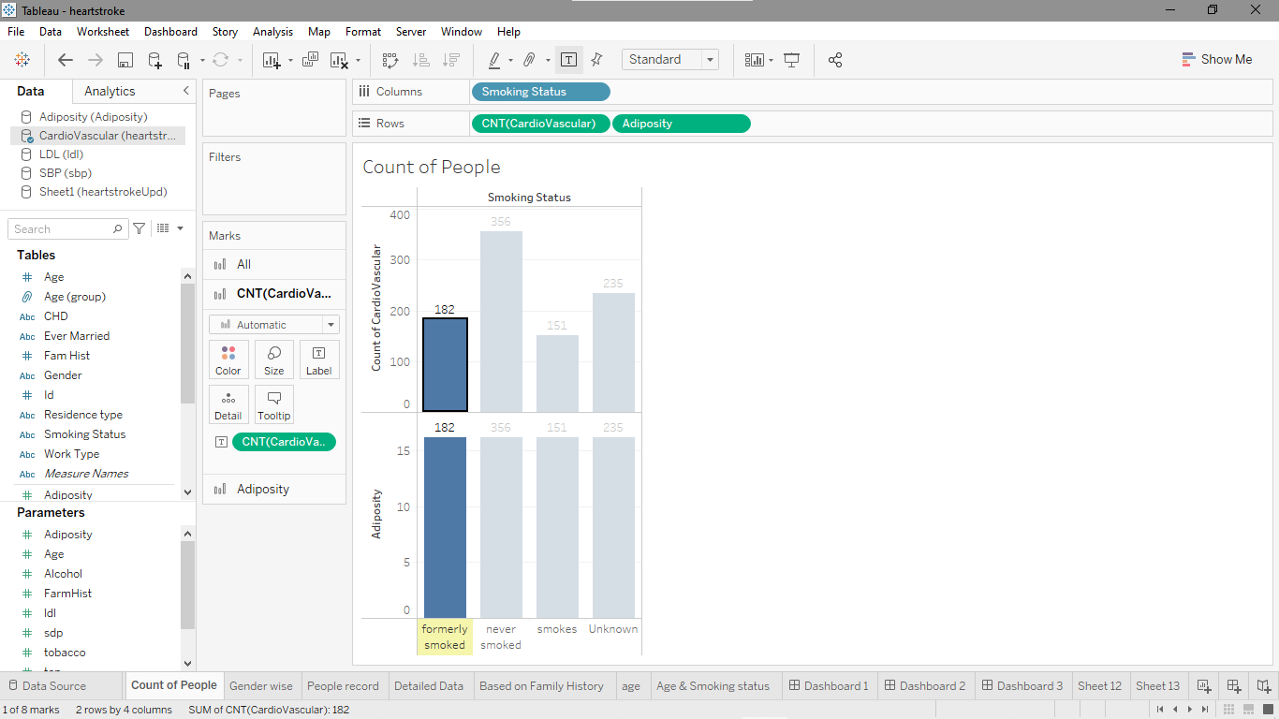

* Grouping the count gender wise

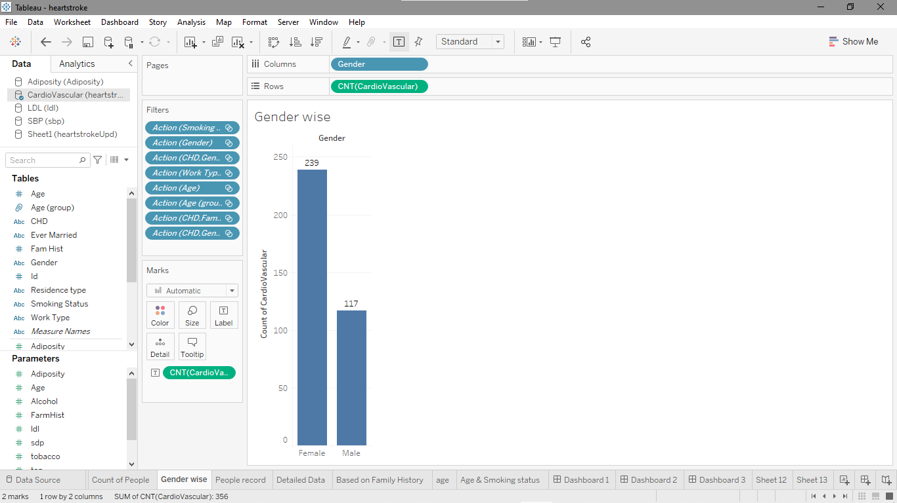

* Calculation of the people records gender wise



* Detailed data for each categories

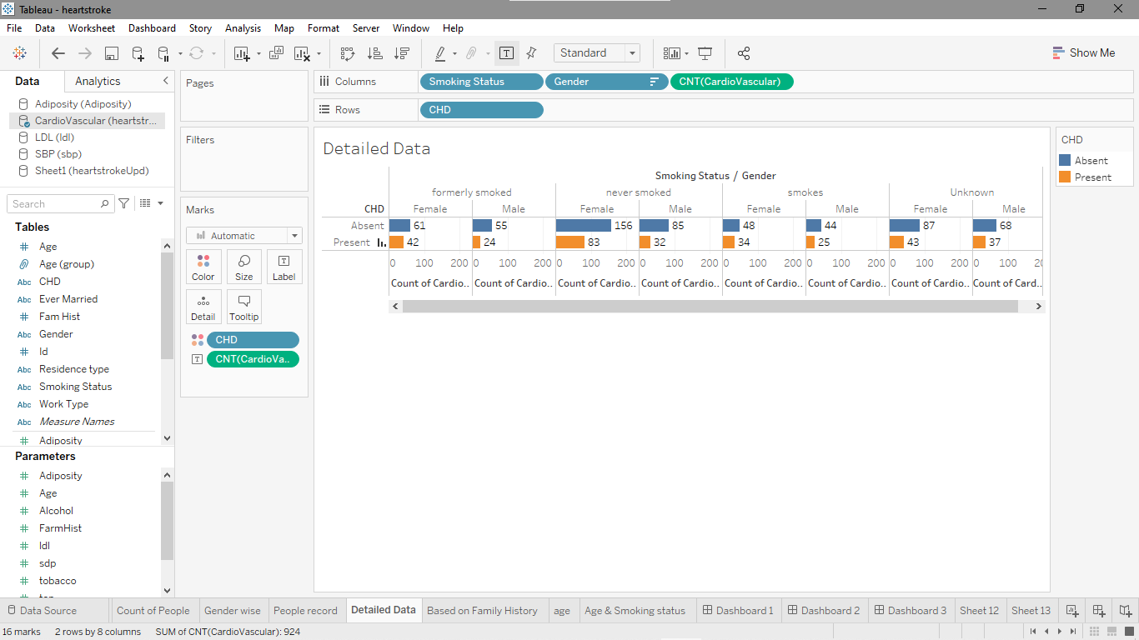

* Analysis based on family history

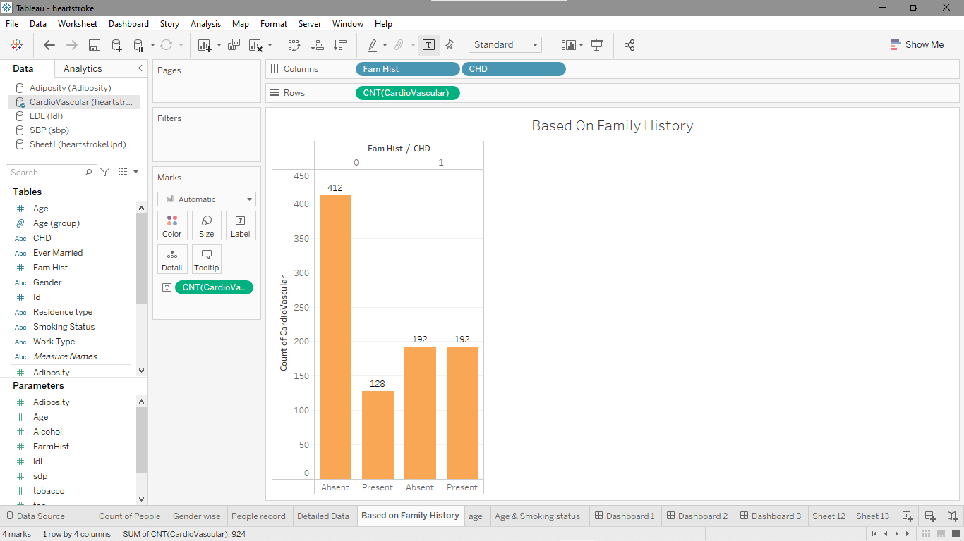

* Merging and grouping based on age

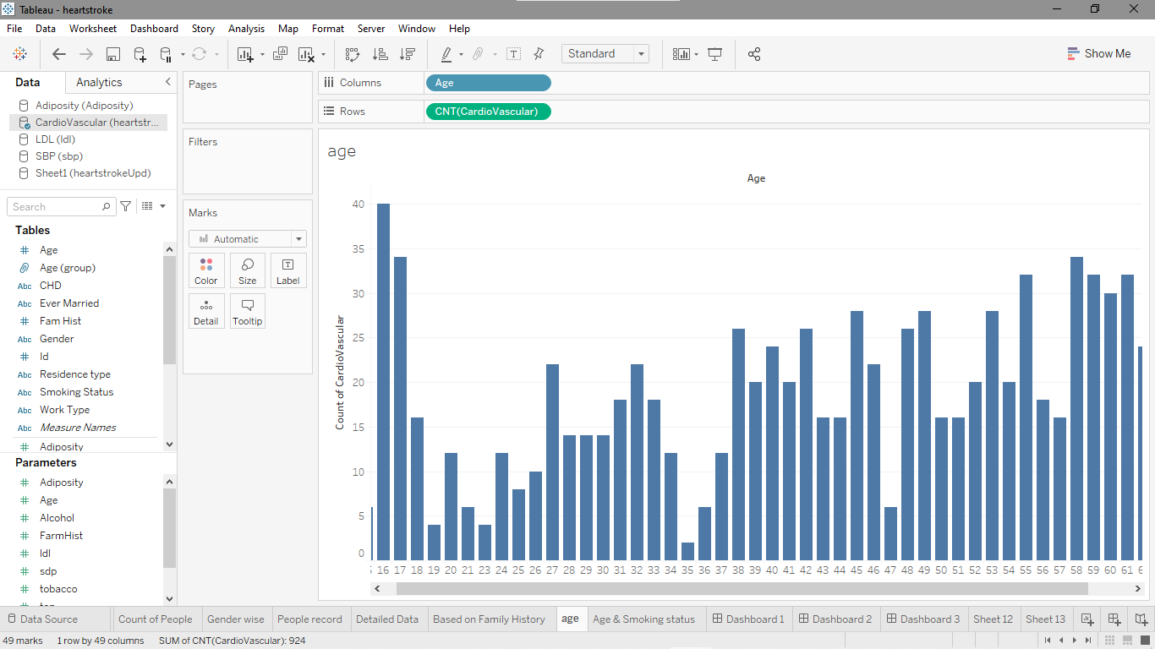

* Merging and grouping based on age and smoking status

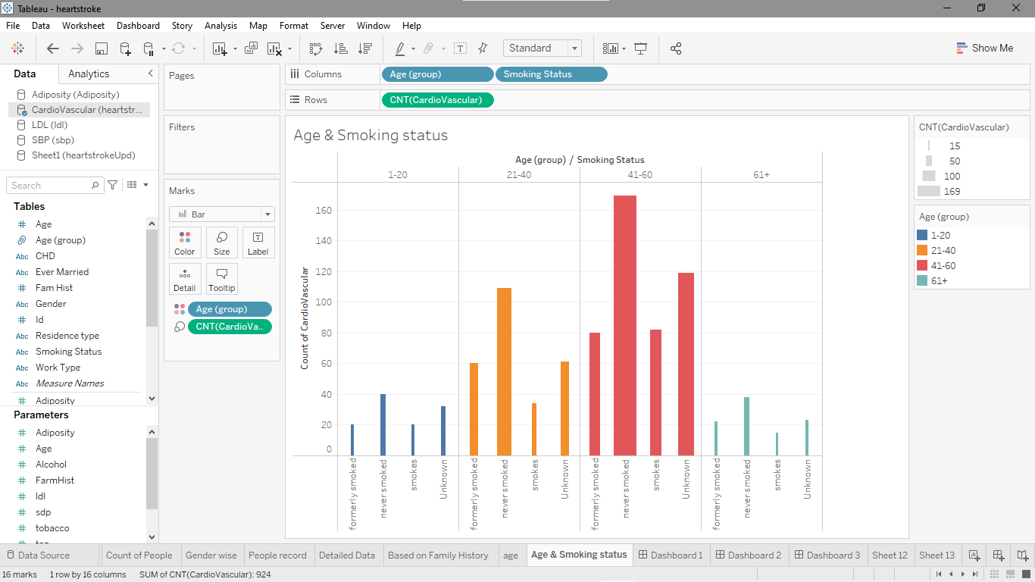

**Predictive modelling(**Using Logistic Regression)

* Model for % of presence

SCRIPT_STR(

"

import pandas as pd

import numpy as np

from ast import literal_eval

from sklearn.linear_model import LogisticRegression

from sklearn.preprocessing import StandardScaler

d={

'ad':literal_eval(_arg1[0]),

'ag':literal_eval(_arg2[0]),

'al':literal_eval(_arg3[0]),

'fam':literal_eval(_arg4[0]),

'ldl':literal_eval(_arg5[0]),

'sbp':literal_eval(_arg6[0]),

'tob':literal_eval(_arg7[0]),

'typea':literal_eval(_arg8[0]),

'chd':literal_eval(_arg9[0])

}

df=pd.DataFrame(d)

X=df.iloc[:,:8]

y=df.iloc[:,8]

sc=StandardScaler()

X_t=sc.fit_transform(X)

lr=LogisticRegression()

lr.fit(X_t,y)

inp_list=[_arg10[0],_arg11[0],_arg12[0],_arg13[0],

_arg14[0],_arg15[0],_arg16[0],_arg17[0]]

inp=np.array(inp_list).reshape(1,-1)

inp=sc.transform(inp)

pred=lr.predict(inp)

prob=lr.predict_proba(inp)

return str(pred[0])

",

ATTR([Adiposity]),ATTR([Age]),ATTR([Alcohol]),ATTR([Fam Hist]),

ATTR([ldl(mmol/L)]),ATTR([sbp(mm Hg)]),ATTR([tobacco(in Kg)]),ATTR([Typea]),

ATTR([CHD]),

[Parameters].[Adiposity],[Parameters].[Age],[Parameters].[Alcohol],

[FarmHist],[ldl],[sdp],[tobacco],[Parameters].[Typea]

)

* Model for % of absence

FLOAT(SCRIPT_STR(

"

import pandas as pd

import numpy as np

from ast import literal_eval

from sklearn.linear_model import LogisticRegression

from sklearn.preprocessing import StandardScaler

d={

'ad':literal_eval(_arg1[0]),

'ag':literal_eval(_arg2[0]),

'al':literal_eval(_arg3[0]),

'fam':literal_eval(_arg4[0]),

'ldl':literal_eval(_arg5[0]),

'sbp':literal_eval(_arg6[0]),

'tob':literal_eval(_arg7[0]),

'typea':literal_eval(_arg8[0]),

'chd':literal_eval(_arg9[0])

}

df=pd.DataFrame(d)

X=df.iloc[:,:8]

y=df.iloc[:,8]

sc=StandardScaler()

X_t=sc.fit_transform(X)

lr=LogisticRegression()

lr.fit(X_t,y)

inp_list=[_arg10[0],_arg11[0],_arg12[0],_arg13[0],

_arg14[0],_arg15[0],_arg16[0],_arg17[0]]

inp=np.array(inp_list).reshape(1,-1)

inp=sc.transform(inp)

pred=lr.predict(inp)

prob=lr.predict_proba(inp)

return str(prob[0][1])

",

ATTR([Adiposity]),ATTR([Age]),ATTR([Alcohol]),ATTR([Fam Hist]),

ATTR([ldl(mmol/L)]),ATTR([sbp(mm Hg)]),ATTR([tobacco(in Kg)]),ATTR([Typea]),

ATTR([CHD]),

[Parameters].[Adiposity],[Parameters].[Age],[Parameters].[Alcohol],

[FarmHist],[ldl],[sdp],[tobacco],[Parameters].[Typea]

))

* Model for getting accuracy

SCRIPT_STR(

"

import pandas as pd

import numpy as np

from ast import literal_eval

from sklearn.linear_model import LogisticRegression

from sklearn.preprocessing import StandardScaler

d={

'ad':literal_eval(_arg1[0]),

'ag':literal_eval(_arg2[0]),

'al':literal_eval(_arg3[0]),

'fam':literal_eval(_arg4[0]),

'ldl':literal_eval(_arg5[0]),

'sbp':literal_eval(_arg6[0]),

'tob':literal_eval(_arg7[0]),

'typea':literal_eval(_arg8[0]),

'chd':literal_eval(_arg9[0])

}

df=pd.DataFrame(d)

X=df.iloc[:,:8]

y=df.iloc[:,8]

sc=StandardScaler()

X_t=sc.fit_transform(X)

lr=LogisticRegression()

lr.fit(X_t,y)

return str(lr.score(X_t,y))

",

ATTR([Adiposity]),ATTR([Age]),ATTR([Alcohol]),ATTR([Fam Hist]),

ATTR([ldl(mmol/L)]),ATTR([sbp(mm Hg)]),ATTR([tobacco(in Kg)]),ATTR([Typea]),

ATTR([CHD]),

[Parameters].[Adiposity],[Parameters].[Age],[Parameters].[Alcohol],

[FarmHist],[ldl],[sdp],[tobacco],[Parameters].[Typea]

)

* Model for getting presence or absence

SCRIPT_STR(

"

import pandas as pd

import numpy as np

from ast import literal_eval

from sklearn.linear_model import LogisticRegression

from sklearn.preprocessing import StandardScaler

d={

'ad':literal_eval(_arg1[0]),

'ag':literal_eval(_arg2[0]),

'al':literal_eval(_arg3[0]),

'fam':literal_eval(_arg4[0]),

'ldl':literal_eval(_arg5[0]),

'sbp':literal_eval(_arg6[0]),

'tob':literal_eval(_arg7[0]),

'typea':literal_eval(_arg8[0]),

'chd':literal_eval(_arg9[0])

}

df=pd.DataFrame(d)

X=df.iloc[:,:8]

y=df.iloc[:,8]

sc=StandardScaler()

X_t=sc.fit_transform(X)

lr=LogisticRegression()

lr.fit(X_t,y)

inp_list=[_arg10[0],_arg11[0],_arg12[0],_arg13[0],

_arg14[0],_arg15[0],_arg16[0],_arg17[0]]

inp=np.array(inp_list).reshape(1,-1)

inp=sc.transform(inp)

pred=lr.predict(inp)

prob=lr.predict_proba(inp)

return str(pred[0])

",

ATTR([Adiposity]),ATTR([Age]),ATTR([Alcohol]),ATTR([Fam Hist]),

ATTR([ldl(mmol/L)]),ATTR([sbp(mm Hg)]),ATTR([tobacco(in Kg)]),ATTR([Typea]),

ATTR([CHD]),

[Parameters].[Adiposity],[Parameters].[Age],[Parameters].[Alcohol],

[FarmHist],[ldl],[sdp],[tobacco],[Parameters].[Typea]

)

**Designed Model in work**

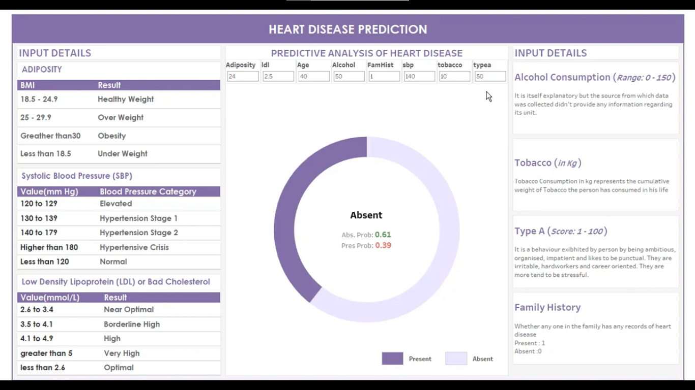

* Dashboard 1

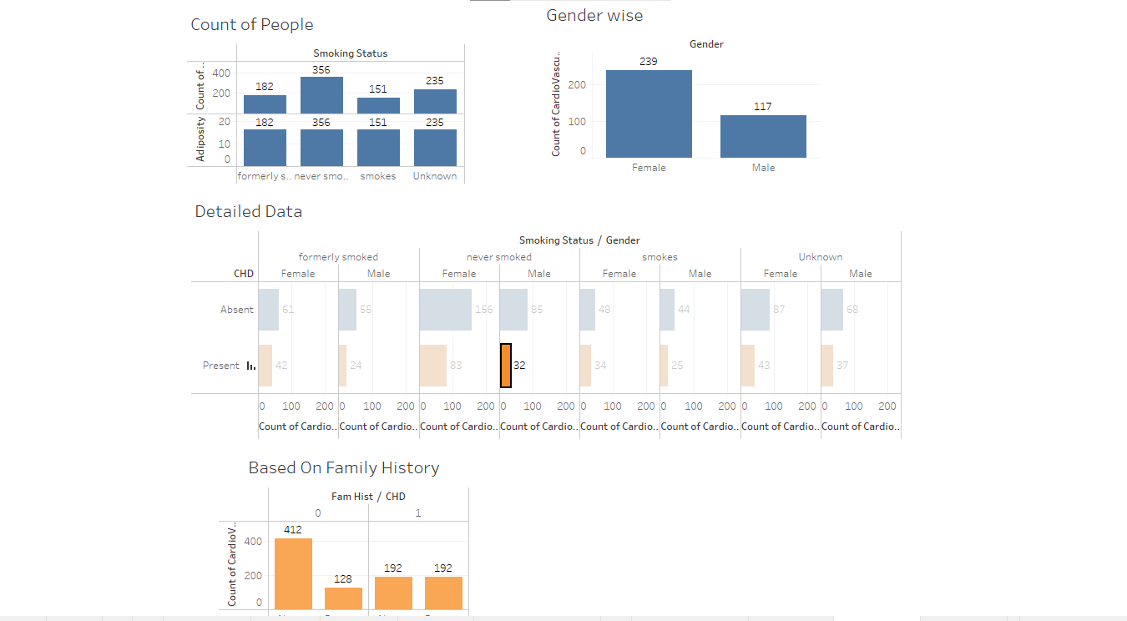

* Dashboard 2